# Project Kickoff: Data Science for Business

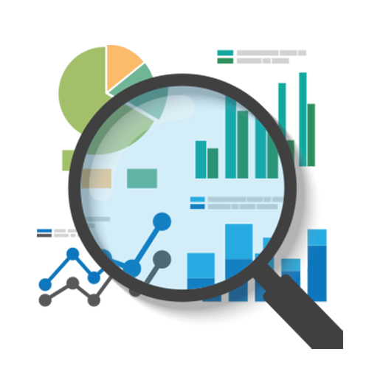

Businesses rely on data to improve their products, efficiency, and more. A data scientist or business analyst works with groves of data to explore and find patterns that would help improve and grow the business.

There are many ways that data can be used to help a business. These include:

* Improving efficiency based on metrics and data.
* Making decisions based on social trends.
* Learning more about customers and a business’s target audience.
* Making better products based on an analysis of customer reviews.
* Predicting the success rate of a new business strategy.

In this project, you will gather (or create) business data that can be used to make decisions about how to better the company or product. You will present your findings in a business report that suggests several action items that you predict will help the business’s performance and growth.